**Problem Statement:**

You have successfully cleared the second semester. In your third semester you will work with joins and update statements.

**Tasks To Be Performed:**

1. Create an ‘Orders’ table which comprises of these columns: ‘order_id’, ‘order_date’, ‘amount’, ‘customer_id’.

**Snippet:**

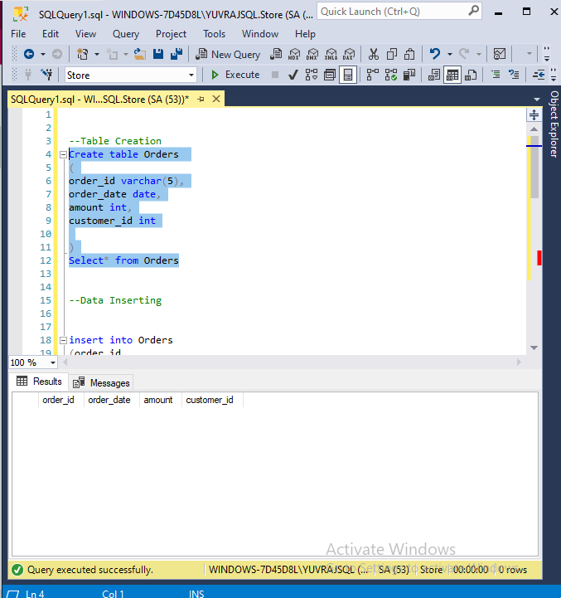

1. Insert 5 new records.

**Snippet:**

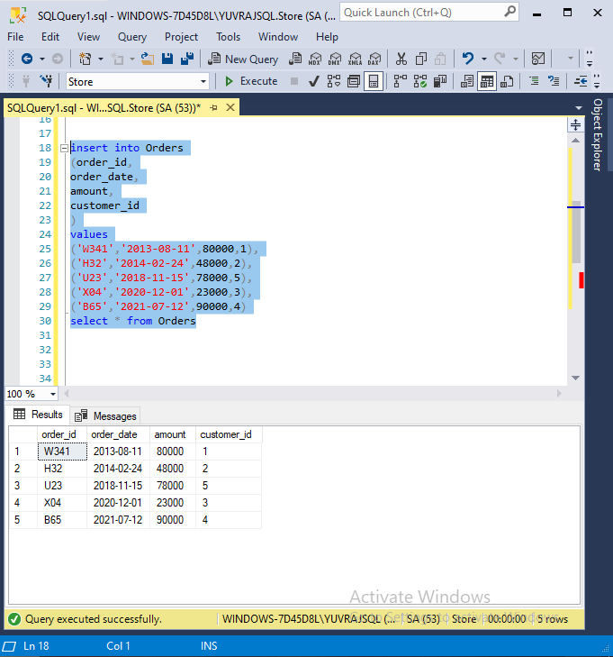

1. Make an inner join on ‘Customer’ and ‘Orders’ tables on the ‘customer_id’ column.

**Snippet:**

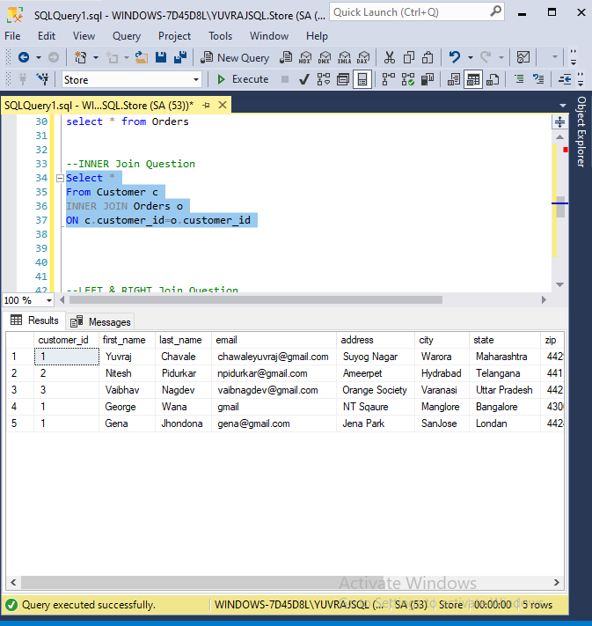

1. Make left and right joins on ‘Customer’ and ‘Orders’ tables on the‘customer_id’ column.

**Snippet:**

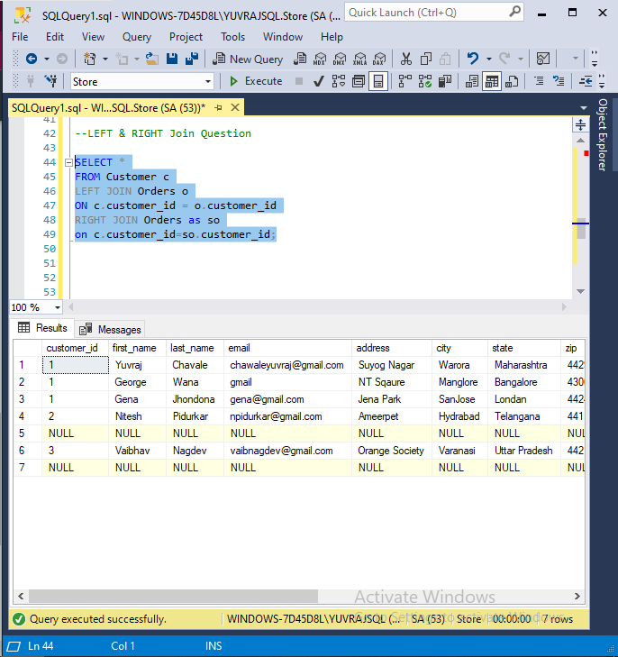

1. Make a full outer join on ‘Customer’ and ‘Orders’ table on the ‘customer_id’ column.

**Snippet:**

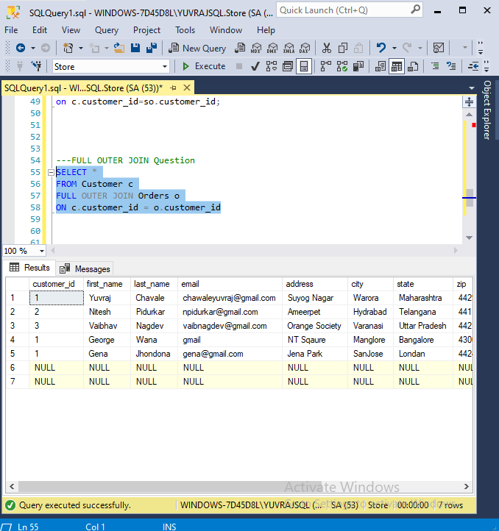

1. Update the ‘Orders’ table and set the amount to be 100 where‘customer_id’ is 3.

**Snippet:**

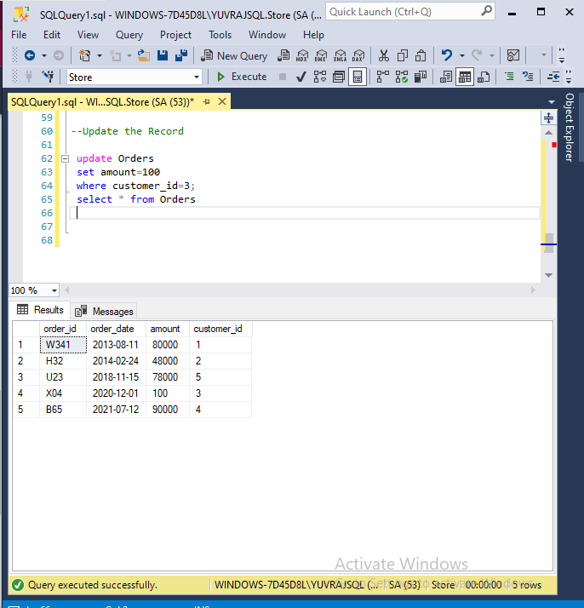

1. **Whole Script For Reference**

--Table Creation

Create table Orders

(

order_id varchar(5),

order_date date,

amount int,

customer_id int

)

Select* from Orders

--Data Inserting

insert into Orders

(order_id,

order_date,

amount,

customer_id

)

values

('W341','2013-08-11',80000,1),

('H32','2014-02-24',48000,2),

('U23','2018-11-15',78000,5),

('X04','2020-12-01',23000,3),

('B65','2021-07-12',90000,4)

select * from Orders

--INNER Join Question

Select *

From Customer c

INNER JOIN Orders o

ON c.customer_id=o.customer_id

--LEFT & RIGHT Join Question

SELECT *

FROM Customer c

LEFT JOIN Orders o

ON c.customer_id = o.customer_id

RIGHT JOIN Orders as so

on c.customer_id=so.customer_id;

---FULL OUTER JOIN Question

SELECT *

FROM Customer c

FULL OUTER JOIN Orders o

ON c.customer_id = o.customer_id

--Update the Record

update Orders

set amount=100

where customer_id=3;

select * from Orders